H.T No
Regulations:
A14

Sreenidhi Institute of Science and Technology
(An Autonomous Institution)
Code No: 4AC41 Date: 12-July-2021 (AN)

B.Tech I-Year II- Semester External Examination, July-2021 (Supplementary)
BASIC Electrical Engineering (BT)

Time: 3 Hours Max.Marks:70

Note: a) No additional answer sheets will be provided.
b) All sub-parts of a question must be answered at one place only, otherwise it will not be valued.
c) Missing data can be assumed suitably.

ANSWER ANY 5 OUT OF 8 QUESTIONS. EACH QUESTION CARRIES 14 MARKS.

Bloom's Cognitive Levels of Learning (BCLL)

Remember | L1 | Apply | L3 | Evaluate | L5
Understand | L2 | Analyze | L4 | Create | L6

 |  |  | BCLL | CO(s) | Marks
1. | a) | Explain the principle of source transformation in electrical circuits. | L2 | CO1 | [7M]
 | b) | 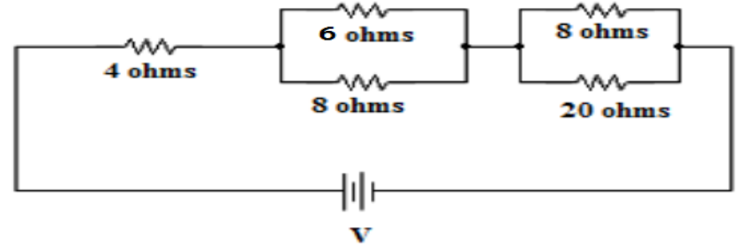  The current in 6Ω resistor of the network shown in Figure.1 is 2A. Determine the currents in all resistors and the voltage across the network.  Figure.1 | L4 | CO1 | [7M]
2. | a) | Define the following terms w.r.t AC waveforms.  (i) frequency  (ii) average value  (iii) r.m.s value  (iv)phasor  (v) form factor. | L1 | CO2 | [7M]
 | b) | A coil has a resistance of 5Ω and draws a current of 20A when connected across a 260V, 50 Hz supply. Determine (i) Inductance of the coil (ii) power factor of the circuit (iii) reactive power. Draw the phasor diagram. | L3 | CO2 | [7M]
3. | a) | Explain the principle of operation of a D.C Generator. | L2 | CO3 | [7M]
 | b) | A 4-pole, lap connected 230V shunt motor has 410 armature conductors. It takes 41A on full load and the flux per pole is 0.05Wb. The armature and field resistances are 0.1Ω and 230Ω respectively. Brush contact drop is 1V per brush. Determine (i) Speed of the motor, (ii) Total torque developed in the motor. | L4 | CO3 | [7M]
4. | a) | Explain the construction and working of a single phase transformer with a neat diagram. | L2 | CO4 | [7M]
 | b) | A 25 KVA , 2500/250 volts, 50Hz single phase transformer gave the following test results  OC Test (LV side) :250V, 4A, 150W  SC Test( HV side) :90V, 10A, 350W  Determine the efficiency and Regulation at full load, 0.8 pf lag. | L3 | CO4 | [7M]
5. | a) | Explain the principle of operation of a three phase induction motor. | L2 | CO5 | [7M]
 | b) | Derive the torque equation of a three phase induction motor. | L3 | CO5 | [7M]
6. | a) | Explain the various methods of providing Controlling Torque in indicating instruments. List their advantages and disadvantages. | L2 | CO6 | [7M]
 | b) | Explain the working of an MI instrument with a neat diagram. | L2 | CO6 | [7M]
7. |  | Find the equivalent resistance across the terminals AB shown in Figure.2 by using star – delta transformations.  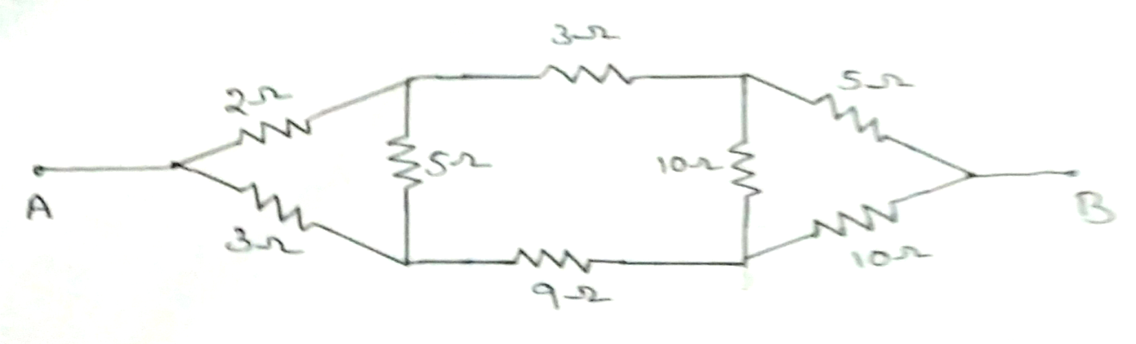  Figure.2 | L3 | CO1 | [14M]
8. | a) | Derive the expressions for converting a delta network to a star network. | L3 | CO4 | [7M]
 | b) | Explain how the range of a PMMC voltmeter can be extended with an example. | L2 | CO5 | [7M]

-- 00 -- 00 –

